[jean-marc.le-ru@ca-gip.fr](mailto:jean-marc.le-ru@ca-gip.fr) – Vmware Build, 20th May 2022

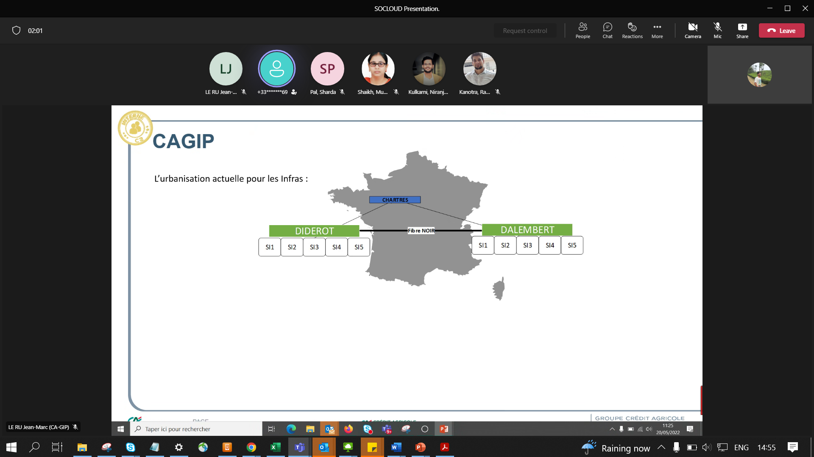

Black fibres b/w sites

4 rooms

SIlca – 3 rooms

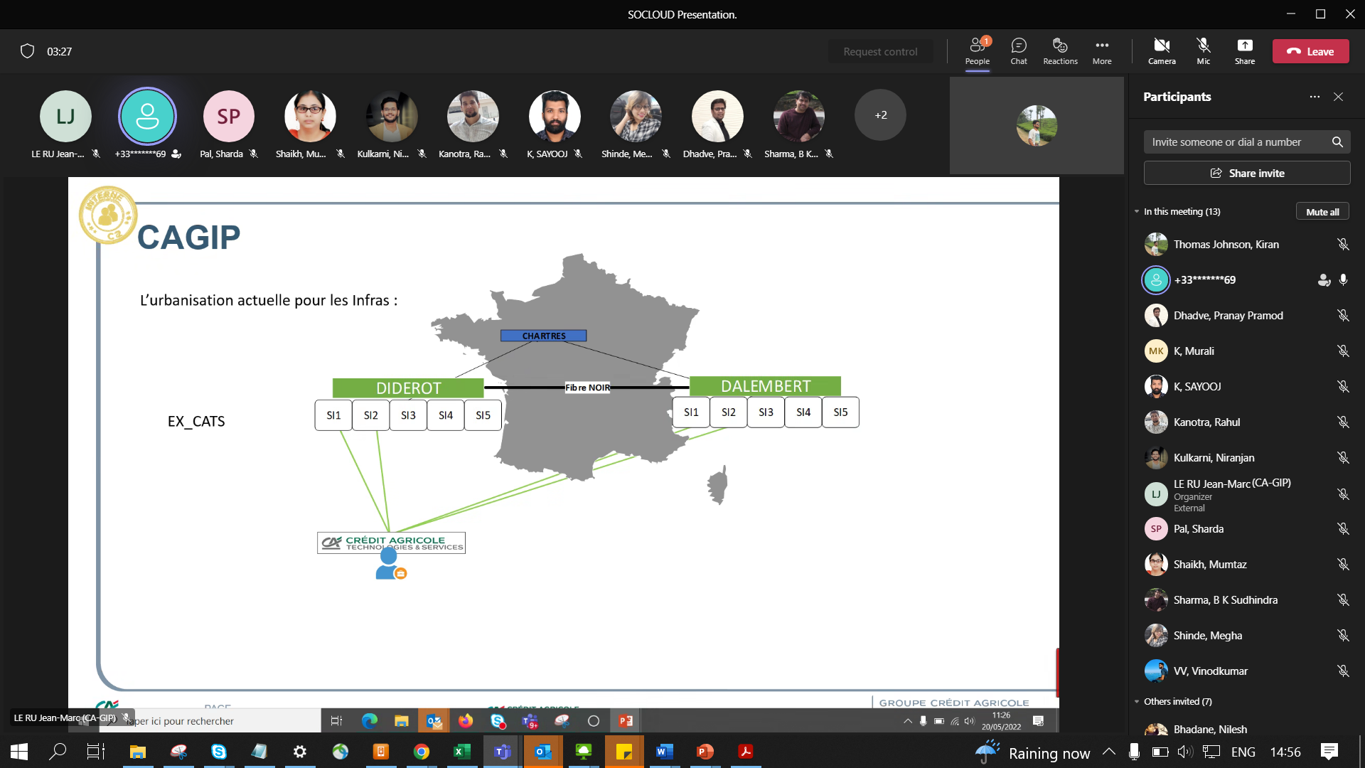

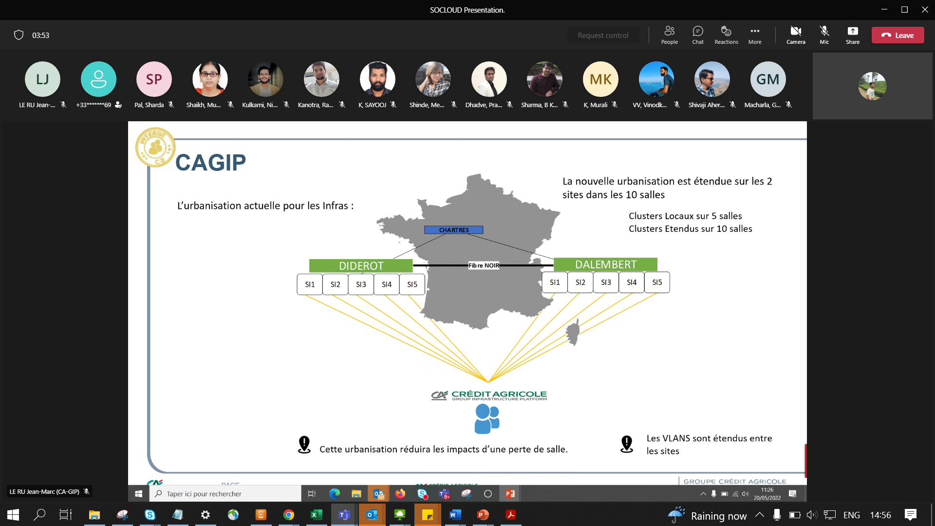

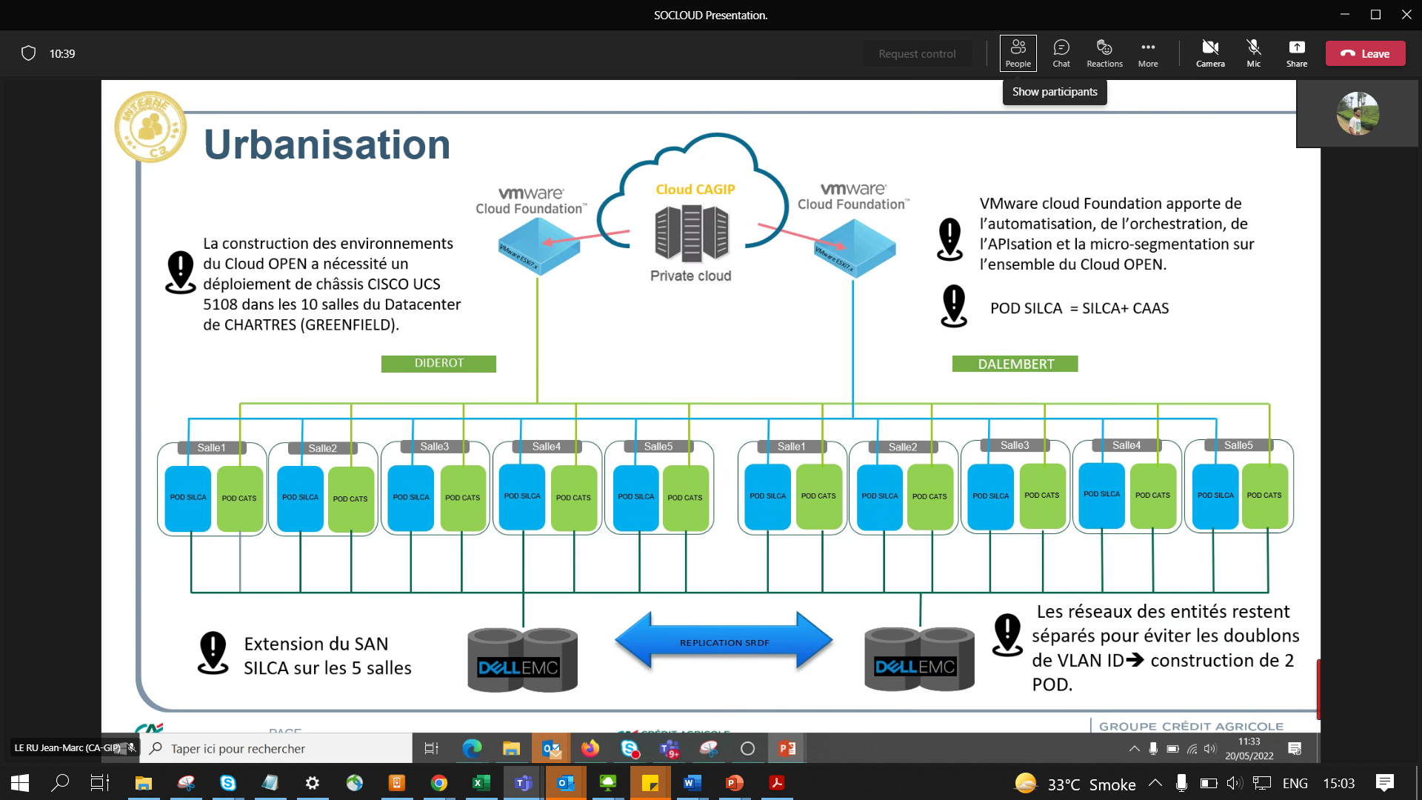

Each rooms -2 racks – cisco eqpmnts

Dell EMC – PMAX 8000 – 2 Peta Bytes capacity

Vmware Cld Fndtn – VCF = for easy administration of all Esx hosts (patching etc..)



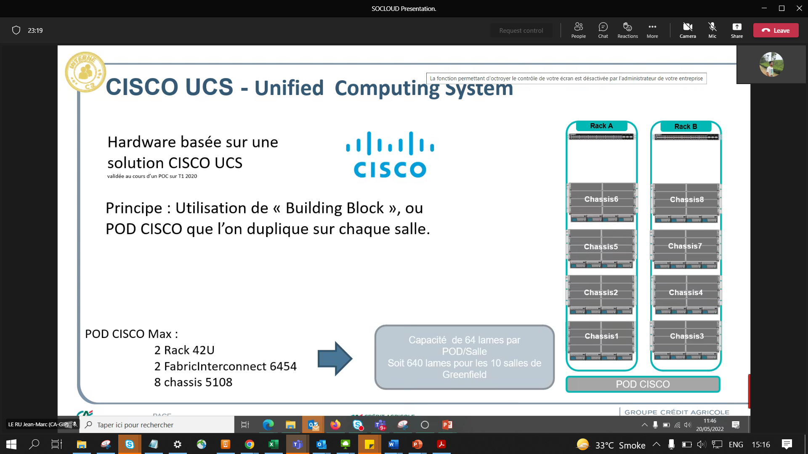

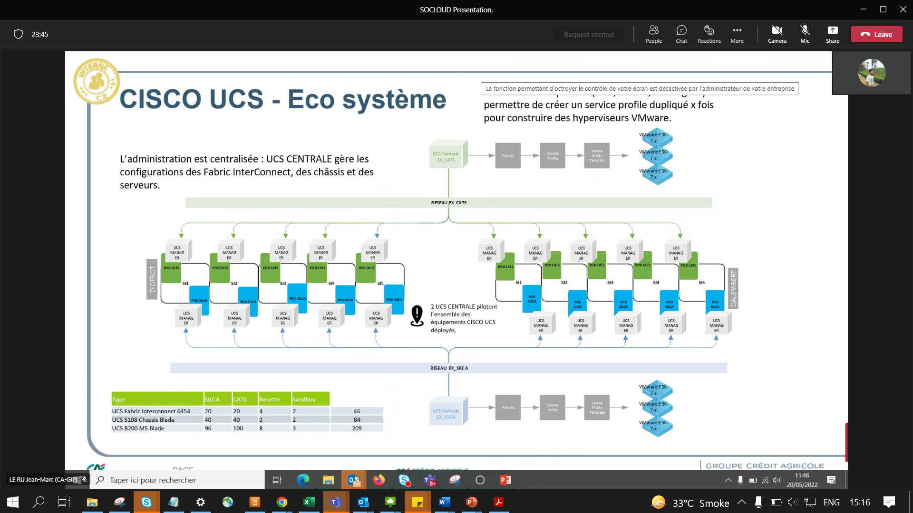

UCS Central manages all UCS Managers in a DC etc..

